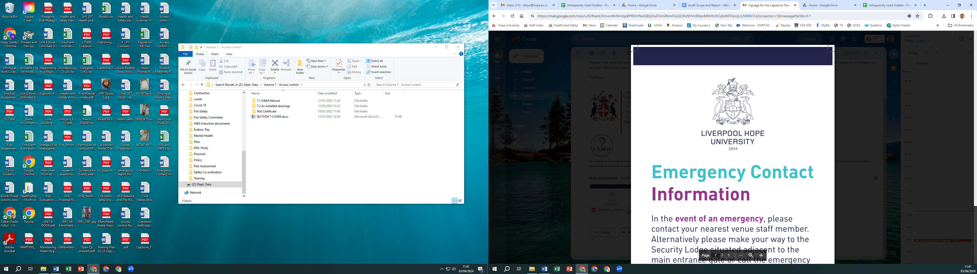

**Liverpool Hope University Business Continuity Plan**

|  |  |
| --- | --- |
| Responsibility for Policy: | Health and Safety Advisor |
| Version: | December 2024 |
| Approved by and date: |  |
| Frequency of Review: | Annually |
| Next Review date: | December 2026 |
| Related Policies: | Student / Apprentice Complaints Policy and Procedure |
| Revisions: | December 2024  Following the introduction of Degree Apprenticeships, the Policy has been updated to include Apprentices. |

Table of Contents

1. Introduction 2

2. Key Objectives of the Plan 3

3. Business Recovery Intent and Priorities 3

4. Roles and Responsibilities 4

5. Business Continuity Management Framework 6

6. Risk Management 6

7. The Business Continuity Management Programme Life Cycle 7

8. Information, Training and Exercising 8

9. Governance Review and Reporting 8

10. Business Continuity Actions 9

11. Continuity of Learning 13

12. Crisis Communication Plan 14

13. Threats and Triggers Hazard Matrix 14

14. Key Contacts for Business Continuity 18

# Introduction

The potential for loss, or disruption of critical activities at Liverpool Hope University requires an effective Business Continuity Plan. Good business practice, health and safety duty of care, student experience and expectations, and regulatory requirements provide important influence in ensuring that the University has proactive plans and procedures to enable response to and management of a major incident or business interruption. Achieving these objectives form part of the University’s commitment to ensure our strategy, solutions, documentation and staff awareness, remains current and effective. Therefore, Liverpool Hope University is committed to the development and implementation of business continuity, appropriate to the scale, nature, complexity and geography of the University, and the relevant environments in which we operate. Liverpool Hope University believes the way in which we plan, prepare and respond to incidents is key to our overall effective recovery and continuance. Business Continuity plays a critical part in the University overall control environment.

This plan is intended to be used cohesively with the Major and Serious Incident Plan, with particular focus on the recovery section, Crisis Communications Policy, IT Disaster Recovery Plan and Shepperd Warlock Special Collections Salvage Plan with shared procedures as follows:

* Incident reporting procedures and invocation of the Business Continuity Plan is identical to that of the Major and Serious Incident Plan.
* The Major and Serious Incident Management Team is also the Business Continuity Management Team with some specific BC roles outlined in this plan.
* Key internal University contacts for the Business Continuity Plan are identical for those of the Major and Serious Incident Plan.
* Designated locations for emergency shelter and triage, and emergency contact numbers for recovery and business continuity are identical to those in the Major and Serious Incident Plan.
* Each of the described plans above will be enacted cohesively dependant on the circumstances of the incident.

Guidance to staff and students on emergency incidents, including the national threat level is available on the University webpage at: [Emergency Information - Stay Safe Principles](https://www.hope.ac.uk/gateway/staff/governance/healthandsafety/staysafeprinciples/).

# Key Objectives of the Plan

The core business functions of academic learning and teaching are at the centre of the plan. Key to this is the speedy return to teaching and scholarly activity and the key stakeholders therefore are the students and staff of the University and Employers of Degree Apprenticeships and their Learners. Objectives are:

* The protection of people, assets, earning capacity, information, reputation, brand and value of the University and its key stakeholders.
* Complying with legislation and regulatory requirements and delivering appropriate governance and reporting processes.
* Providing adequate resources to achieve delivery of the Business Continuity Plan.
* Providing appropriate education and training to all staff to increase their awareness and to enable them to understand their roles and responsibilities.
* Embedding Business Continuity as an integral part of the University’s operations and good management practice.
* Reviewing Business Continuity ‘best practice’ and updating the University’s Business Continuity Plan and standards accordingly.
* Developing procedures to assess the effectiveness of Business Continuity plans and carry out testing annually, based upon pertinent scenarios.

Liverpool Hope University business continuity plan provides preparedness procedures for and ensure that in respect of the following incidents:

* Risks to people and the business are properly identified, evaluated, recorded and managed.
* Measures to avoid or reduce the risk are implemented at an acceptable cost.
* Risks, and the measures implemented to control them, are reviewed regularly to ensure their continued viability and relevance.
* All legal, regulatory and duty of care requirements are met.
* Develop a robust Business Continuity capability through ‘fit for purpose’ plans and appropriate education and training for all staff to increase their awareness and skills.

# Business Recovery Intent and Priorities

Following a disruption or incident, the following business continuity intent and priorities will apply:

*‘The intent during a disruption is the continued provision of higher education to our students in a safe operating environment.’*

To achieve this intent, Liverpool Hope University maintains the following priorities:

|  |  |  |  |
| --- | --- | --- | --- |
| People | Education | Assets | Reputation |
| *Safety and well-being of:*  Staff, contractors and visitors  Students and Degree Apprenticeship  Next of Kin | *Minimising disruption to:*  Education and research  Assessments/exams  Recruitment  Student experience | *Protecting:*  Data  IT Infrastructure  Physical Infrastructure and accommodation | *Protecting reputation through:*    Communication with internal stakeholders  Communication with external stakeholders |

# Roles and Responsibilities

The overall ownership and accountability for Business Continuity is with the Responsible Person and Major and Serious Incident Management Team. Business continuity roles at Liverpool Hope University are separated into **Planning** (i.e. pre-incident) roles and **Invocation** (i.e. during and post incident) roles. Key response roles following a major incident, as shown below:

Planning Organisation (Pre-Incident) Invocation Organisation (During and Post-Incident) Key roles and responsibilities

|  |  |  |
| --- | --- | --- |
| Role | Responsibilities during business as usual | Responsibilities during a disruption |
| **Major and Serious Incident Team** | Actively supports the Business Continuity Plan.  Allocates adequate resources and budget to business continuity.  Approves the business continuity plan  Ensures continued effectiveness of the management approach.    Attends annual training and exercise.  Meets to review Business Continuity Management, and progress, issues.  Reports annual Business Continuity Management status to UEB.  Sets the schedule for the coming year. | Forms the Strategic BC Team.  Sets policy and direction.  Assess impact and plan response and recovery    Provide direction to Schools and Supports Departments  Manage resources |
| Role | Responsibilities during business as usual | Responsibilities during a disruption |
| **Designated Responsible Person** | University Emergency Management Team Co-ordinator  Owner of the University’s Major and Serious Incident plan.  Accountable for ensuring that appropriate business continuity arrangements are implemented for the processes, systems and other resources upon which the university depends.  Develops and maintains the business continuity programme, which describes how, by whom and with what frequency the various elements of the business continuity arrangements, are to be tested.  Acts as the business continuity expert throughout the university.  Supports all aspects of tenders and client assurance relating to business continuity.  As required reports to UEB on the status and progress of business continuity. | Leads the strategic BC  Team  Assists UEB as necessary with adherence to processes. |

Specific Key Roles and Responsibilities

|  |  |
| --- | --- |
| Role | Responsibility |
| **Deans of Schools, and Directors and Heads of Service** | Internal drivers and supporters of BC who will lead on the response process in their respective areas and the further embedding of business continuity across the University |
| **University Staff** | Contribute to the business continuity planning process  Share information on how their functions are delivered  Have awareness of BC plans and procedures once developed.  Work in accordance with any BC plans and procedures should they be activated following a business interruption |
| **Director of Estates** | Responsibility for identifying and sourcing alternative accommodation for teaching and office space, if required  The Estate |
| **Campus Services Manager** | Security and facilities |
| **Director of Marketing and Communications** | Responsibility for maintaining a Crisis Communications Response Plan, for effective communication with staff, students and other stakeholders |
| **Director of IT Services** | Responsibility for the provision and maintenance of data, telecommunications and IT systems and networks, and for ensuring a robust and suitable response to data and/or telecoms failures. |
| **Director of People Services** | Responsibility for staffing response and continued business for loss of people |
| **Director of Student Services** | Responsibility for arranging the provision of essential student services during and following an emergency. |
| **Chief Operating Officer** | Responsibility for managing emergency expenditure and liaison with the University Insurers |

# Business Continuity Management Framework

* Risk Management and Crisis Management – This is managed by means of the University M&SIT, risk register management, Oversite Group, UEB and Audit Committee.
* Business Continuity and Business Recovery – M&SIT with focus on mitigation, reducing the likelihood and impact of incidents and disaster. Management of incidents, supplemented and influenced as appropriate by external stakeholders (i.e. by MFRS in the event of a fire)
* ‘Plan B’ Procedures: how can we continue to operate with the loss of facilities/staff/technology etc. Back to ‘Plan A’: getting facilities/staff/technology back and returning to business as usual or using opportunity to improve upon.

*These components are inter-related as per the diagram below:*

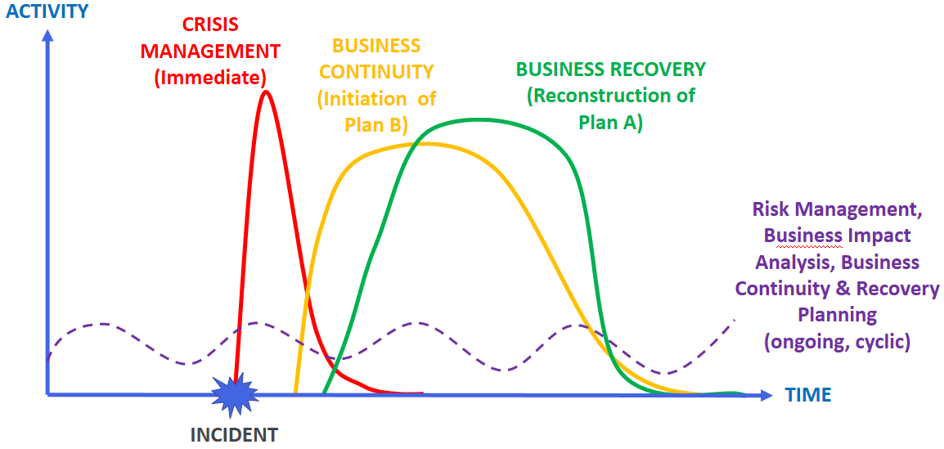

# Risk Management

The procedure for risk management at the University is structured by means of local risk registers and the institutional risk register. As stipulated in the Risk Management Policy, all Schools and Departments are expected to own a risk register. These are to be revised on a regular basis and are reviewed by the Risk Management Oversight Group and UEB Periodically.

The Risk Management Oversight Group monitors the institution’s performance in identifying, assessing, prioritising and mitigating key risks related to all aspects of the University’s activities and provides guidance in relation to the management of risks. This includes identifying trends amongst local risks registers and escalating up to an institutional level if required. The Risk Management Oversight Group report to UEB to provide assurance on risk management at a local level.

# The Business Continuity Management Programme Life Cycle

Business Continuity strategies, solutions and plans are complex and require considerable effort to maintain, communicate and exercise. The Business Continuity Institute (BCI) – an internationally recognised good practice authority – recommends the following approach, a life cycle based on the Plan-Do-Check- Act model: The University will consistently implement the Plan-Do-Check-Act model for Business Continuity Management cycle as below.

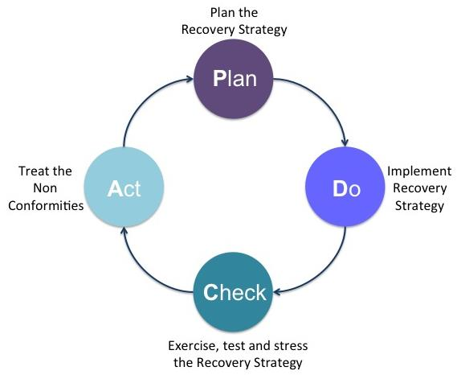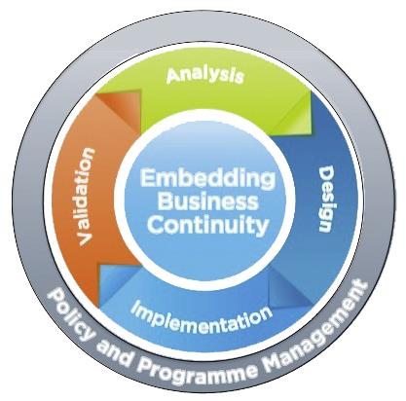

Analysis

The first step is to **analyse** what the priority business continuity activities are for the University. These are the critical functions that must continue and/or be recovered as quickly and as effectively as possible. This will be captured through effective strategy and risk management.

Design

The design phase identifies and selects appropriate strategies and tactics to determine how recovery from disruption and continuity will be achieved. The design phase of Business Continuity enables Liverpool Hope University to determine and document appropriate Business Continuity strategies. This incorporates:

* A response structure that allows the University to respond to any given disruption in an appropriate and proportionate manner.
* Recovery options that enable us to meet the recovery times identified for each critical activity.
* Mitigation measures that will reduce the likelihood and or reduce the impact of the identified threats.

Implementation

Liverpool Hope University Major and Serious Incident Plans and related crisis/disaster management continuity and recovery plans enable the university to execute agreed strategies. The plans identify and document the priorities, procedures, responsibilities and resources to assist response in managing disruption, while implementing continuity and recovery strategies to a pre-determined level.

Validation

Validation is the phase that confirms that Business Continuity is meeting the identified objectives and that the university’s arrangements are fit for purpose. The purpose of validation is to ensure that the Business Continuity capability reflects the nature, scale and complexity of Liverpool Hope University to ensure it is current, accurate, and complete, with actions taken to continually improve business continuity.

# Information, Training and Exercising

Testing is an on-going process. Exercising and testing the business continuity capability and competence falls into three categories:

* Emergency Response: emergency evacuation drills should be undertaken twice yearly.
* Cascade Call: testing the key contacts callout should take place every year.
* Scenario: there should be a scenario-based workshop exercise with the Major and Serious Incident Team every year.

Recovery Testing: tests of the recovery strategies should be carried out annually. Such tests will encompass technology and/or user exercises.

To assist with coordinating the estates team response, important information relating to the University’s physical estate has been compiled into an emergency information portfolio. All relevant staff will be briefed on their roles and responsibilities within it on an annual basis. This portfolio is stored on university servers under the following link.

Z:\Estates\EstatesArchive\0. Disaster Recovery File

Instruction and training on emergency planning matters will be through a range of measures including the University’s Health and Safety Consultative Committee, IT Services Committee, Estates Team meetings, working groups, toolbox talks, induction procedures and formal training.

# Governance Review and Reporting

To assure compliance with the Business Continuity Plan and that an appropriate level of Business Continuity Management capability is developed and maintained, Business Continuity is to be reported to the University Executive Board (UEB) on an annual basis, or more frequently when considered necessary.

The Major and Serious Incident Team will meet at the end of each academic year to answer and report to UEB on the question:

Is our Business Continuity Plan still fit for purpose?

The agenda will address the question:

* Is our Business Continuity Plan appropriate?
* Does it consider organisational changes that have occurred in the past year?
* Have there been any major technology upgrades, additions that are no longer covered by the current solution(s)?
* Do the recovery strategies meet regulatory and University’s requirements?

The review should consider the results and recommendations from tests and exercises conducted over the past year alongside the findings of the most recent Risk Assessment.

# Business Continuity Actions

# 10.1. Business Continuity Strategy for Loss of People

The loss of people on campus could have a significant impact on the University’s ability to meet its strategic objectives. This may be due to one key member of staff being absent for a prolonged period, several staff being away (due to extreme weather, illness, industrial action etc.) or even a pandemic situation which requires the University to close.

Responsibilities:

* Senior members of staff (Deans, Directors and School Managers) should, where possible, respond to incidents out of hours where required. All Schools and Departments should maintain an up-to-date list of out-of-hours contact details for key/relevant staff and this must be shared with Campus Services.
* All University managers should have a named deputy who is aware that it is their responsibility to deputise in the event of their being unavailable during a crisis/period of disruption.
* It is the responsibility of Deans, Directors and School Managers to ensure that they maintain a list of key staff and a plan to mitigate the loss of key staff.

Loss of staff:

* In the event of a large number of staff being absent in one area, the Director of People Services will organise members of the People Services team to support arrangements for secondment where possible.
* In the event of a large number of staff being absent across the institution, the People Services team will seek arrangements with fellow Universities to ensure adequate support is in place.
* The UEB will determine if the University should close.

Loss of Senior Management:

* In the absence of a Dean for a prolonged period of time, the UEB should be consulted to agree on interim arrangements.
* In the absence of a Director, the Head of Governance will determine if interim arrangements are required.
* In the event that a School Manager is absent, the Executive Dean will determine if interim arrangements are required.
* Directors and Heads must ensure that their annual leave arrangements do not result in there being a lack of leadership in the event of a crisis/period of disruption.

Loss requiring emergency funding:

* In the event of a crisis situation, it may be necessary to make emergency purchases. The Schedule of delegation stipulates that the Chief Operating Officer can approve individual emergency purchases above the procurement threshold.

In addition, following a technology or estates incident, additional People Services support may be required to support the Major and Serious Incident team and affected members of staff. Mutual aid from a fellow city institution (potentially involving the secondment of staff) may be required to ensure the People Services team is equipped to do this whilst maintaining business as usual.

Business Recovery Strategy for Loss of People

This will normally require back to work interviews and may involve meetings with occupational health if required and phased returns arranged. This may put added pressure on the People Services Team, and additional support may be required for a period of time (i.e. mutual aid from fellow institution). Managers are expected to check in with staff who have returned to work to ensure that they are adequately supported.

# 10.2. Business Continuity Strategy for Loss of Buildings

# (*also see specific response table on page 9*).

The loss of building spaces on campus may be temporary and *short term* (e.g. access issue, minor security issue, false alarm fire evacuation, severe weather disruption), *medium term* (e.g. loss of access to a specific building area or room due to localised fire, loss essential services like gas or water within a building, or localised flooding), or *long term* (e.g. total loss of an essential infrastructure system, or a total loss of a building through fire). The University will manage this by:

* Prioritise site security and containment of any dangerous areas to enable and assist Merseyside Fire and Rescue Service investigation and loss adjuster assessments.
* The Estates and Campus Services team will receive strategic direction from the M&SIT to serve the needs of the University in the event of a catastrophic failure which would prevent the use of parts or the whole of a building or campus.
* Schools and Departments will receive strategic direction from M&SIT to enable them to initially deal with the immediate problems posed by a loss of space or access to key facilities on campus whilst the Estates and Campus Services teams work to contain the issue and make the area / property safe by bringing the incident to a defined conclusion.
* The M&SIT will appoint the operational team to work with affected Schools and Departments to instigate medium term Business Continuity Plans leading to temporary accommodation solution (*instigate Plan B solution*)
* Estates and Campus Services will organise temporary accommodation solutions for situations where a short*-term* plan is required in the event of significant disruption on campus. This will involve the procurement of a temporary accommodation on site, with student housing or seeking ‘mutual aid’ from North West and city University neighbours.
* Appoint project team to oversee the development of refurbishment works/ new build project to return operations to original business operations long term via long term actions and Business Continuity Plans (*return to Plan A*).
* Estates and Campus Services will work with the affected School or Department to reinstate their operations. This activity may require minor adjustments (e.g. working with IT to relaunch door security), may be a medium-term activity (e.g. a refurbishment following a flood), it might be a substantial undertaking (e.g. new build replacement property).
* Crisis kits are located at each campus within the security lodge or within the main office at Plas Caerdeon. Each kit contains useful information and equipment to assist the initial emergency response following a major incident. If a Major Incident is declared, the estates disaster recovery team members will be notified by the Director of Estates.

# 10.3 Business Continuity Strategy for Loss of IT Infrastructure and Technology

The business continuity strategy has been subject to Business Impact Analysis as detailed in the IT Disaster Recovery Plan. A summary of the plan objectives are below:

## IT Services Disaster Recovery Plan

The University relies heavily on the IT facilities to provide the required services to students, apprentices, academics and administrative staff. Consequently, IT services are a critical component in the daily operations at the University, requiring a comprehensive *IT Disaster Recovery Plan.*

This plan is reviewed and updated yearly by IT Services and approved by the Pro Vice Chancellor (Research).

Due to the uncertainty regarding the magnitude of any potential disaster on the campus, the plan will only address the recovery of systems under the direct control of IT Services and that are critical for business continuity. This includes the following major areas:

* Servers
* Data Networks (networks, data storage)
* Logon facilities
* Desktop Equipment (Offices, Classrooms, Labs)
* Administration Services (Student Record Management (SRM), SITS, E-Reporter, CIPHR)
* Finance (Agresso)
* Electronic Mail and Internet Services
* Learning Resources (Network drives, Library facilities, Moodle)
* Miscellaneous Services (Accommodation and Conferencing System, Security Access Control System, E-Profile, Course Design and Approval)

The plan covers all phases of any IT related disaster. These phases include:

* Incident Response
* Assessment and Disaster Declaration
* Incident Planning and Recovery
* Post Incident Review

### IT Disaster Recovery Plan Testing

The two major criteria are the ability to recover the business process within their Recovery Time Objectives with data at the defined Recovery Time Objective.

The ability to recover business critical applications is tested as set out in the Electronic Data Backup Policy and Procedures.

# 10.4 Management of students and staff – Loss of site or teaching spaces

Students and apprentices attend the University by whatever means of transport is accessible to them. Liverpool Hope has learner car parks and is serviced by bus routes from all areas of the city. For those learners travelling from further afield the University in served by both a local airport and train stations. This also ensures that the Universities personnel can attend off site activities with ease due to the strong transportation infrastructure. In the case of an incident the following responses will be instigated.

# 10.5 Planned specific response action table for buildings, accommodation and teaching spaces

|  |  |  |
| --- | --- | --- |
| Scale of Major Incident | Planned Response | |
| **Non-Residential Assets** | **Residential Assets** |
| **Small**  **e.g. loss of standalone teaching building or loss of single hall of residence** | Move timetabled teaching to alternative teaching accommodation on campus (Consider use of conference spaces, designated places of assembly and HPS for additional temporary teaching accommodation)  Setup hot desk facility on campus for staff directly affected by loss of accommodation (assistance required from ITS).  Notify employers of Degree Apprenticeships of any relevant changes | Students brought together in designated place of assembly (refer to Major Incident Plan Guidance for Staff); Provide emergency welfare (e.g. access to hot showers, toilets, catering provision, emergency bed packs, consider use of exam chairs stored within HPS, pastoral care provided by SDW and Residential Life teams)  Students rehoused within University managed halls void rooms &/or guest accommodation (Consider cancelling short-term guest bookings to prioritise students). |
| **Medium**  **e.g. loss of larger more critical teaching building** | As above with the addition of;  In the event of insufficient teaching accommodation being available on campus, move timetabled teaching to alternative University campus location  Notify employers of Degree Apprenticeships of any relevant changes  In the event of insufficient office space being available on campus, staff relocated to hot desk facility at alternative University campus location. | As above with the addition of;  In the event of insufficient University managed accommodation being available, University to source additional provision from third party providers &/or local hotels (Refer to third party accommodation provider contact list). Transportation to be provided via taxi or University coach provider. |
| **Large**  **e.g. loss of entire campus** | As above with the addition of;  In the event of insufficient teaching accommodation being available on alternative University campus, consider cancelling planned teaching sessions that cannot be accommodated and/or contact third party partners local of affected campus to provide emergency accommodation.  In the event of insufficient office accommodation being available on alternative University campus, staff requested to work remotely.  Notify employers of Degree Apprenticeships of any relevant changes  Notify the ESfA if Learners of Degree Apprenticeships are affected in terms of their Off the Job learning | As above with the addition of;  In the event of insufficient third-party accommodation being available, consider sending students home until sufficient temporary accommodation can be established or University managed accommodation brought back online. |

# 11. Continuity of Learning

Students including Apprentices and Learners may not have access to the Internet, tech equipment, phone lines, TV or radio at all or for a period of time during a prolonged closure or absence. Therefore, it is important to offer a variety of methods of distance learning. Liverpool Hope will abide by the Equality Act, 2010 and ensure materials will be provided in alternative formats, when necessary.

The University has used Moodle as a learning platform for over 20 years without any incidence therefore we remain confident that the impact on students and learners of a ‘outage’ where they can no longer access learning resources, or their portfolio remains low risk.

Apprentices will be using an external learner platform (i.e. Aptem) for completing and submitting their work. The learners will also be responsible for keeping a copy of all submitted work outside of the system to ensure ongoing access to their learning resources and portfolio in the event of the need for a continuity plan being evoked.

The external provider i.e. Aptem has their own continuity plan for any system outages which can be provided on request. Should an unforeseen incident occur for instance Aptem going into administration we can be confident that Academics and learners are storing their work in systems that we have confidence in.

This plan will be reviewed annually in the Academic committee led by Deputy Vice Chancellor and Provost.

## 11.2 Supporting Apprentices if the University can no longer deliver training

In the unlikely event that we are no longer in a position to deliver Apprenticeship training we will recognise this well in advance of any situations where learners will be negatively impacted or the University’s reputation damaged. However, if we find ourselves in a position where training must end we would take the necessary action for learners and their studies to be safeguarded by finding them an alternative provider for their studies to continue. We would work hard to ensure effective recording of prior learning (RPL) took place and that learners could where possible continue with their integrated degree with another institution.

# 12. Crisis Communication Plan

The University has a Crisis Communications Guidance Document detailing the strategy for managing internal and external communications during a crisis.

The Crisis Communications Plan is owned and updated by the Head of Corporate Communications. All external communications to journalists and media are to be co-ordinated by the University’s Major Incident Team

The method of communicating will be determined by the facilities available. Potential methods of communication include: -

* Notices on the University Web Site
* Updates on key applications such as the Student Record Management (SRM), SITS and Moodle
* Telephone updates to key areas such as Student Administration, Faculty Offices, Finance, Library, Student Union, People Services, Telephone Switchboard
* Recorded messages on telephones
* Posters in key areas such as Library, Halls of Residence, Building Reception areas, classrooms
* Personal visits to appropriate areas of the University

Following any incident, appropriate action must take place to ensure that members of the University community, and others as necessary, receive information to bring closure to the incident.  Consideration will also be given to identifying and implementing measures to improve the action plan used during the incident

# 13. Threats and Triggers Hazard Matrix

The hazard matrix on page 15 identifies key hazards which could cause a disruption with main triggers for plan activation as partial or total loss of one or more of the following:

|  |  |
| --- | --- |
| 1 | Staff and/or students/teaching |
| 2 | Buildings, facilities or equipment |
| 3 | Utilities or other critical services e.g. water or electrical suppliers |
| 4 | Communications or computer systems e.g. data, network, servers, telecommunications |
| 5 | Business critical suppliers, contractors or partners |

|  |  |  |  |  |  |  |  |  |  |  |  |
| --- | --- | --- | --- | --- | --- | --- | --- | --- | --- | --- | --- |
| Threat and Trigger Hazard Matrix | | | | | | | | | | | |
| **Threat** | **Hazard** | **Likelihood** | | | **Impact** | | | **Response Triggers** | **Response Actions** | **BC issues (impact of failure)** | |  |
|  |  | **Almost Certain** | **Possible** | **Rare** | **Major** | **Moderate** | **Minor** |  |  |  | |
| **Major health incident** | Pandemic or Major health outbreak |  | X |  | X |  |  | Communicable disease notified by PHE | Implement communicable diseases protocol | Loss of staff and students  Increased cleaning regimes (infection control) | |
| **Major weather incident** | Extreme weather events e.g. wind damage, flooding, or snow, disruption lasting more than 24hr | X |  |  |  |  | X | Reports of structural/building damage  Weather forecasts | Salvage operations  Source alternative accommodation Communications Plan | Loss of buildings impact on office and teaching space  Utility interruption – power supply Road/transport disruption impact on staff and  students’ ability to get to campus | |
| **Major incident within LHU campuses** | Fire/serious building damage |  |  | X | X |  |  | Emergency services/Incident response team | Building Evacuation then as above | Loss of buildings  Impact on office and teaching space | |
| Utility failure e.g. power failure, loss of water |  | X |  | X |  |  | Incident response team | Supply of generators/ Close buildings | Loss of facilities e.g. lifts  Access to PC’s, equipment,  welfare issues e.g. lighting, heating, water, toilets, hygiene, etc  Loss of building(s) | |
| Terrorist attack (IED, MTA, VAW, NB&C, FAW) |  |  | X | X |  |  | Police/Incident response | Invacuation/evacuation/police led | Loss of buildings impact on office and teaching space | |
| Hostage situation |  |  | X | X |  |  | Police/Incident response | Invacuation/evacuation/police led | Loss of buildings impact on office and teaching space | |
| Bomb threat |  | X |  | X |  |  | Police/Incident response | Invacuation/evacuation/police led | Loss of buildings impact on office and teaching space | |
| Leaks from hazardous materials |  |  | X | X |  |  | Emergency Services/Incident response team | Emergency Management Plan | Loss of area of campus impact on office and teaching space | |
| Industrial action/student protests | X |  |  |  | X |  | Notification from Unions | Manage situation | Loss of staff impact on teaching  Loss of students attending lectures etc.  Loss of buildings impact on office and teaching space | |
| **Major IT failure** | Loss of IT, cyber incident |  | X |  | X |  |  | IT – availability impaired | IT DR plan activated | Access to information, data, communications,  teaching materials, online exams, assessments Web site, internet access | |
| Loss of telephony |  | X |  | X |  |  | No telephone service | Use of email and mobile phones | Impact on communication | |
| Cyber-crime | X |  |  | X |  |  | Slowness and non- responsive IT systems | Network and systems will be shutdown. BIA will need to be activated | Loss of data, no access to IT | |
| **Major incident outside LHU Campus** | Incident oversees |  |  | X | X |  |  | Contact via third party e.g. police, FCO | Set up helpline Communications Plan | Possible impact on service delivery Loss of staff and students  Closure of campus |  |
| No access to student accommodation |  |  | X |  | X |  | Contact via third party | Rest centre provision Alternative accommodation | Loss of students (return home)  Private provider to have BC plans in place |
| Fuel Shortage |  | X |  | X |  |  | Via media or local resilience forum | Provide services remotely | Loss of staff (& students), impact of staff  undertaking critical activities and getting to campus |
| Collapse of major supplier or ‘service provider’ |  | X |  |  | X |  | Via media or ‘notice period’ | Find alternative suppliers/providers | Impact on service delivery |

# 14. Key Contacts for Business Continuity

|  |  |
| --- | --- |
| Responsibility | Reference |
| Medical Emergency  Contact Campus Services | Refer to [University’s Infectious Diseases Policy.](https://www.hope.ac.uk/media/gateway/staffgateway/governance/healthandsafetydocuments/Infectious%20Disease%20Policy.pdf) |
| Fire  RP; Chief Operating Officer  Key University contacts;  Director of Estates, Campus Services Manager. | Key information available within Crisis Kit and on Estates Archive drive  Refer to [University’s Fire Safety Policy](https://www.hope.ac.uk/media/gateway/studentgateway/supportandwellbeing/studentadministrationdocuments/t4_416325_Media.pdf). |
| Asbestos  Asbestos Coordinator – Director of Estates  Key University contact – Estates Surveyor | Refer to University Asbestos Management Plan and Emergency Flowchart contained within.  Asbestos Register available on TEAMS database on following link;  <https://portal.aec.uk.net/Account/Login?ReturnUrl=%2f>  Guest Login – Username (Contractor20) Password (Contractor20) |
| Water Hygiene  Duty Holder – Vice Chancellor  Responsible Person – Director of Estates  Deputy Responsible Person – Estates Maintenance Manager | Refer to University Legionella Management Plan and Emergency Flowchart contained within. |
| University Insurance  Key  University contact -  University Procurement Manager | Broker - Aon  Insurer – Allianz |

14.1 Mutual Aid University Contacts

Liverpool City Region University Business Continuity planning leads meet during each academic year to discuss support and mutual aid in the event of crisis or continuity support requirement.

|  |  |
| --- | --- |
| **University** | **Contact Number** |
| University of Liverpool | **0151-794-2000** |
| Liverpool John Moore’s University | **0151-231-2121** |
| Edge Hill University | **01695575171** |

## 

## 14.2 Key External Contacts

|  |  |  |
| --- | --- | --- |
| Organisation | Contact details | Notes |
| Loss of gas supply  Or if you can smell gas or suspect a gas leak, or are experiencing pressure problems contact National Gas Emergency helpline | 0800 111 999 | <https://cadentgas.com/emergencies-safety/smell-gas> |
| Loss of electricity supply  Distribution Network Operator (DNO)  SP Energy Networks | 105  0800 001 5400 or  0330 1010 400 from mobile | <https://www.ssebusinessenergy.co.uk/contact-us/loss-of-supply/>  Refer to schedule of meters within Crisis Kit |
| Loss of water supply  Contact United Utilities Water and sewerage emergencies helpline | 0345 072 6083 | <https://www.water-plus.co.uk/help-and-support/water-and-wastewater/water-supply-issues> |
| Dangerous Structures **Key University contact;** **Director of Estates, Campus Services Manager, Estates Services Manager** Liverpool City Council Building Control:  Report a Dangerous Structure as the result of damage to buildings from severe weather/natural events, malicious attack or technical failure; collapsed and damaged | 0151 233 0339 | <https://forms.liverpool.gov.uk/contour-forms/reporting-dangerous-structure/>  Refer to Building Manuals saved in estates archive drive  Z:\Estates\EstatesArchive\1. Building Manuals |
| Liverpool City Council Civil Contingencies  Merseyside Police  Merseyside Fire and Rescue Service  North West Ambulance Service | 0151 709 6010  0151 296 4000  0151 260 5220 | <https://liverpool.gov.uk/crime-prevention-and-emergencies/emergency-services/> |
| Police | Tel: **999** (24 hour)  Tel: **101** (24-hour, non-emergency number) | Merseyside Police **0151 709 6010**  <https://www.merseyside.police.uk/> |
| Fire & rescue service | Tel: **999** (24 hour) | Merseyside Fire and Rescue Service **0151 296 4000**  <https://www.merseyfire.gov.uk/> |
| Ambulance service | Tel: **999** (24 hour) | North West Ambulance Service **0151 260 5220**  <https://www.nwas.nhs.uk/> |
| National Health Service | Tel: **111** (24 hour) | <https://www.nhs.uk/> |
| Foreign, Commonwealth & Development Office | Tel**: 0207 008 1500** (24-hour, consular assistance)  If abroad, please dial:  +44207 008 1500 | [Foreign, Commonwealth & Development Office](https://www.gov.uk/government/organisations/foreign-commonwealth-development-office) |
| Environment Agency | Tel: **0845 988 1188** (24-hour, flood line) | [Environment Agency](https://www.gov.uk/government/organisations/environment-agency) |
| Met Office | Tel: **0370 900 0100** (24-hour, weather desk) | <https://www.metoffice.gov.uk/> |
| Health and Safety Executive | Tel: **0845 300 9923** (office hours, incident contact centre)  Tel: **0151 922 9235** (24-hour, duty officer)  Tel: **0151 922 1221** (24-hour, duty press officer) | [Ways to contact HSE](https://www.hse.gov.uk/contact/contact.htm#:~:text=Please%20call%200151%20922%201221). |
| Loss of learning | OIA  DfE  ESFA | My OIA <https://www.oiahe.org.uk/>  DfE <https://www.gov.uk/contact-dfe>  DfE helpline 0370 000 2288  ESFA [SDE.servicedesk@education.go.uk](mailto:SDE.servicedesk@education.go.uk) |

14.3 Contractor Contacts – Also refer to emergency call out list contained within each Security Lodge.

|  |  |
| --- | --- |
| Contractor | Reference |
| Transportation Provider | Selwyns  <http://selwyns.co.uk/contact-us/> |
| Third Party Accommodation Providers | Liverpool Student Homes - 0151 794 3296 <https://www.liverpoolstudenthomes.org/Accommodation>  UNITE  <https://www.unitestudents.com/liverpool>  Liberty Living  <https://www.libertyliving.co.uk/student-accommodation/liverpool/> |